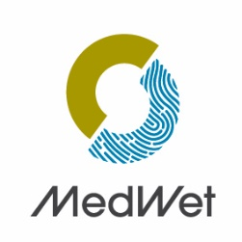

World Wetlands Day 2026
in the Mediterranean

Rights-of-use Authorization

I, the undersigned…………………………………………………………………………………………., legal representative of
………………………………………………………., acting as………………….. …………………………………………………………………
domiciled…………………………………………………………………………………………………………………………………………..

grant free of charge the right to use copies and provide documents and photographs realized as part of this call for projects.

Done in………………………………………….., Date……………………………………………….

Signature

