Mediterranean wide participation in the training course on
visitors’ management in protected wetlands
Valsaín, Spain, 24th July 2017.
The training course on “Visitors Management in Protected Wetlands: Making them the allies of conservation” which is taking place on 24-29 July 2017, is being organised by the Spanish Ministry of Agriculture, Fisheries, Food and Environment (MAPAMA), the MedWet Initiative and the Polytechnic University of Valencia. Twenty seven participants from sixteen Mediterranean countries from both the Northern and Southern shores are participating in the training making it a truly multicultural knowledge and experience sharing course. The course is taking place in the National Centre of Environmental Education (CENEAM) located in Valsaín, Spain.
The course is designed and conducted by the Polytechnic University of Valencia (UPV) which has played a leading role in research, teaching, training, and technical assistance related to protected areas and heritage sites, including tourism and recreational activities. This particular training is addressed to planners, managers, policy makers and people working in public use issues who are increasingly faced with the challenges and opportunities of operating in environments where tourism is or will be a dominant factor in management.
The participants of the training come from the field of environmental protection holding professional positions within protected areas, research institutions and their respective Ministries of Environment. Through this five day intensive course they will learn how to better understand, monitor and manage visitors’ use in order to maintain the quality of the resource while ensuring a satisfactory visitors’ experience in protected areas and heritage sites, particularly in wetlands.
The course will be participatory in nature and will include exercises to develop participants’ skills in building support for wetland conservation and protection, wetlands tourism enhancement, and other skills related to the provision of socio-economic benefits to local communities. By the end of the course, the participants will have acquired the knowledge, skills and tools to identify, diagnose, assess, define and apply strategies and plans to address public use and tourism issues in protected areas.
This course is taking place on the occasion of the UN’s International Year of Sustainable Tourism for Development and aims to raise awareness on the benefits of tourism in protected wetlands but also to highlight the need for efficient management that not only safeguards the natural environment from tourism pressures but also amplifies the benefits by educating the visitors on the values of the ecosystems in question.
More information
Read the program of the training
Contact
Communications Mailis Renaudin mailis@medwet.org
Training Course Maria José Vinals mvinals@upv.es

Photos
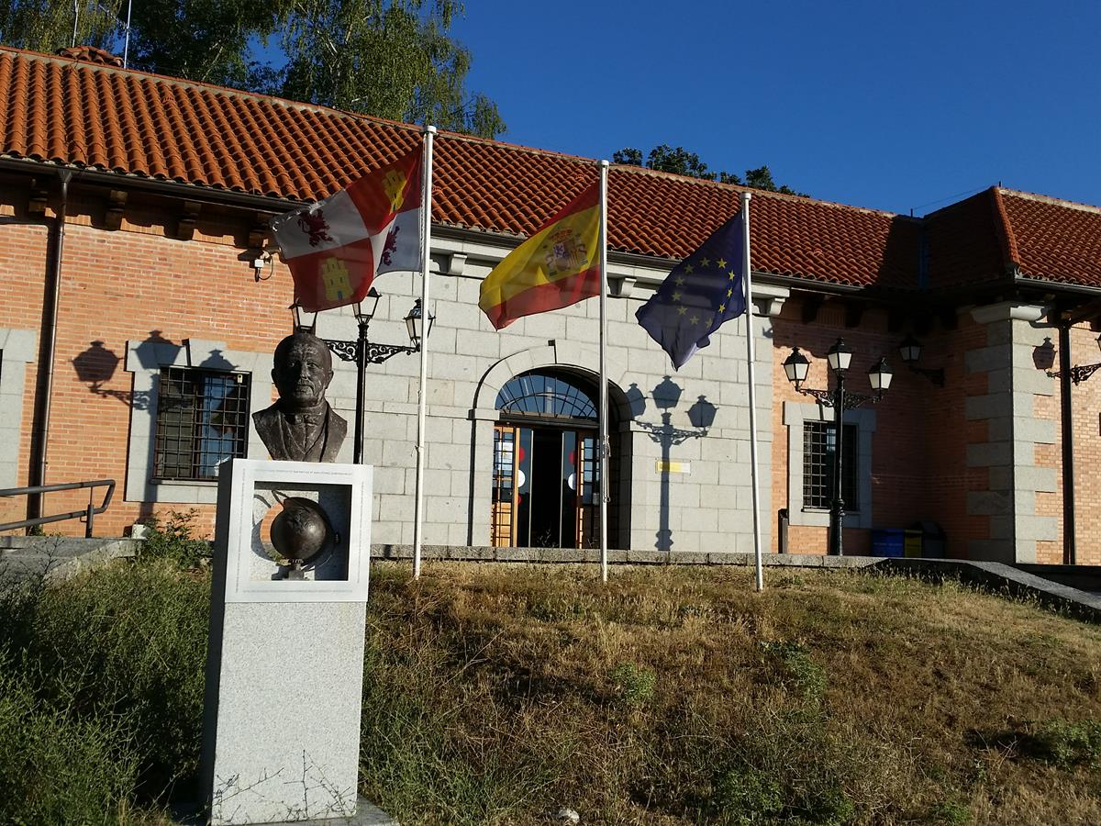
National Centre of Environmental Education (CENEAM) located in Valsaín, Spain. Credit MedWet
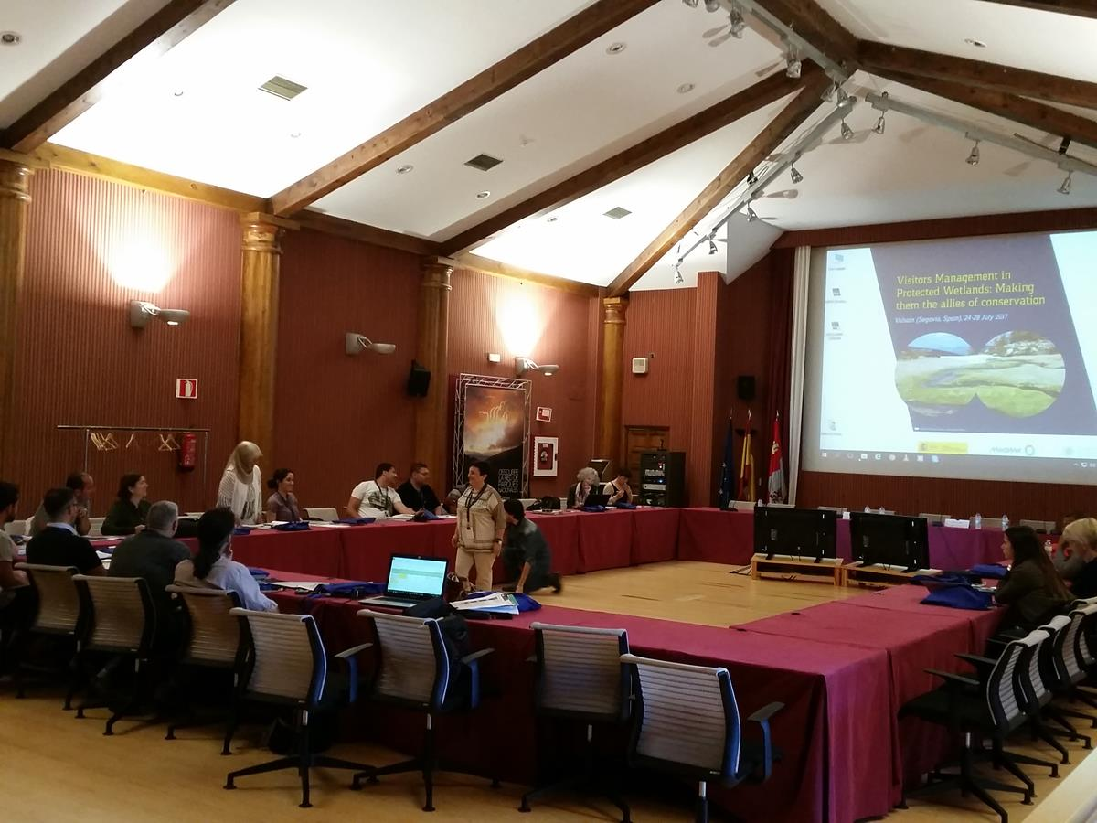
Plenary session at National Centre of Environmental Education (CENEAM) located in Valsaín, Spain. Credit MedWet

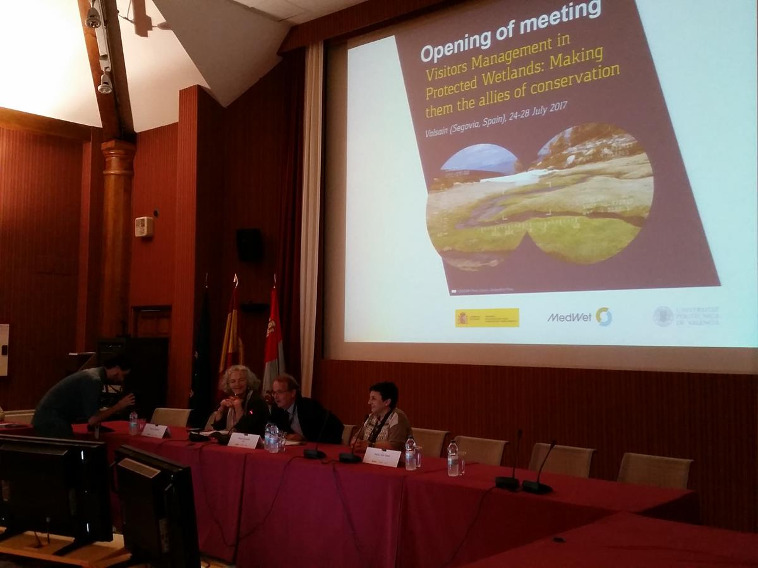
Official opening by M. Aymerich, Spanish Ministry of Agriculture and Fisheries, Food and Environment at National Centre of Environmental Education (CENEAM) located in Valsaín, Spain. Credit MedWet
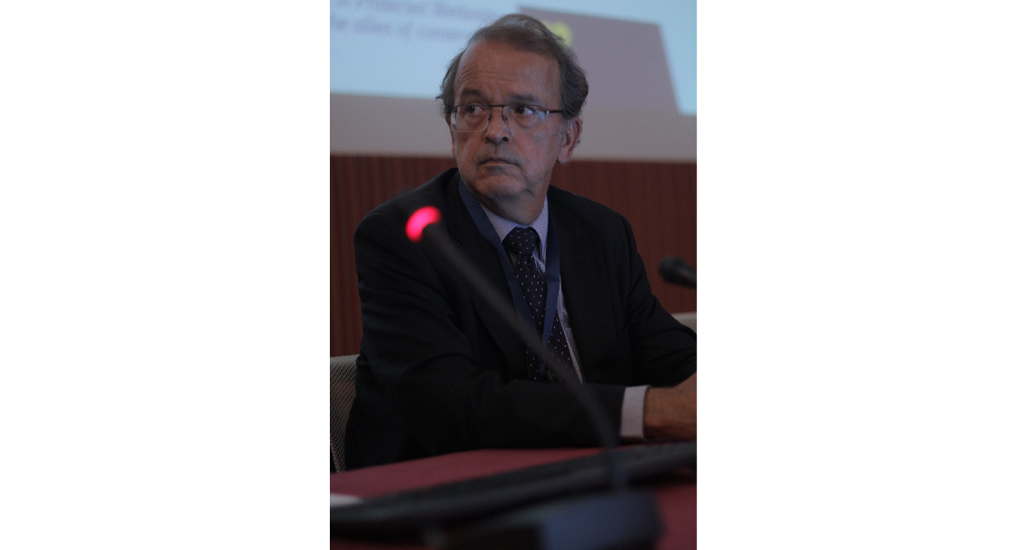

Official opening by M. Aymerich, Spanish Ministry of Agriculture and Fisheries, Food and Environment at National Centre of Environmental Education (CENEAM) located in Valsaín, Spain. Credit M. Dares.
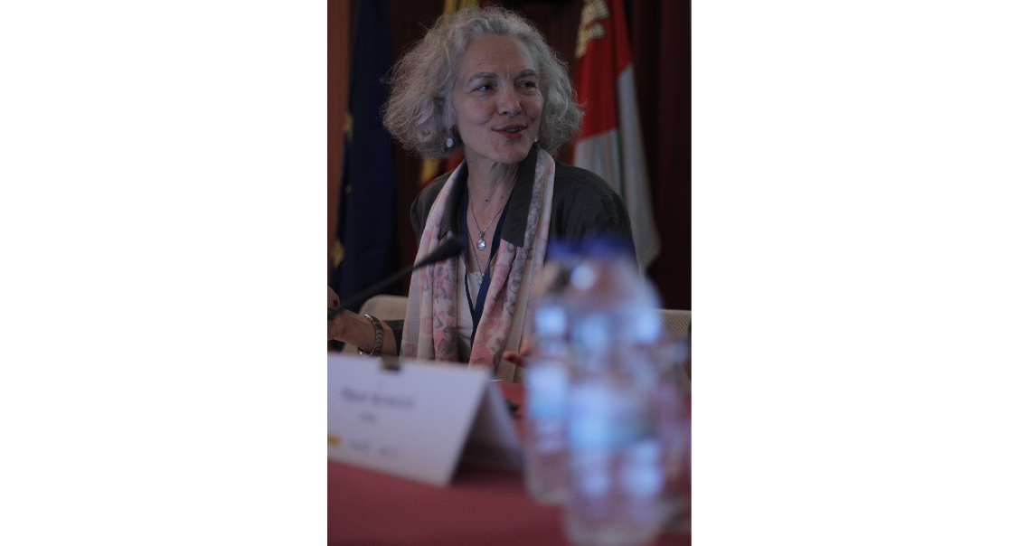
Mrs Gordana Beltram (Slovenia), Chair of MedWet, the Mediterranean Wetlands Initiative. credit M. Dares.
Mrs Maria José Vinals (Spain), Polytecnic University of Valencia (UPV), credit M. Dares.

