TITRE =
Bandeau photos/ cartes

High-profile wetlands in France
Land-cover in Ramsar Sites in Metropolitan France, 1975-2005

French Ramsar Sites: threatened natural jewels

Natural wetlands are essential for biodiversity but also for human populations that benefit from their multiple services: protection against floods, water-table recharge, water purification, etc. In France, these habitats have been transformed by Man since ancient times for productive uses, notably agriculture. With demographic growth and technological developments, this process has accelerated, and wetlands have lost at least 50% of their surface area during the 20th century.

The designation as a Ramsar Site provides international recognition to the most important wetlands in the world. Out of the 44 sites designated by France, 33 are metropolitan. As part of the National Wetland Observatory run by the Ministry of Environment, land cover was studied in 2015 in 32 of these sites (those designated before 2015), on the basis of satellite images. Using the methodology developed under the GlobWetland2 Project (2009-2013, in partnership with Ramsar and the European Space Agency), land cover was mapped in all sites in 1975, 1990 and 2005, and the evolution of both natural and manmade wetlands was measured.

Since it was developed for large-scale assessments, the method provides overall trends for the 32 sites, but site-specific maps should not be interpreted from too local a perspective. Furthermore, as Ramsar Sites are likely better protected than average wetlands in France, the figures should not be taken as representative of national trends for all wetlands.

A high diversity of wetlands, internationally recognized

The 32 French metropolitan Ramsar sites →

- The 32 Ramsar Sites are spread all over metropolitan France, covering a total of 8045 km². Their surface area varies from 0.33 km² (Moltifao peatbogs in Corsica) to over 2,850 km² (Lakes from Wet Champagne).

- Twenty-five out of 32 sites have more than half their surface covered with wetlands. Overall, the 32 sites are made up of 39% wetland habitats. This proportion is highly variable between sites, depending on whether their delineation followed the exact border of wetland habitats or not.

Photo d’un site Ramsar avec pancarte Conservatoire du Littoral ou RNN etc. , et Ramsar
- About half the area of the 32 Ramsar Sites occurs within a Natural Regional Park; the same proportion belongs to the Natura 2000 network. A much lower share (1 to 5%) is protected either as a Nature Reserve, or through land ownership by the state coastal conservancy trust (“Conservatoire du Littoral”). But in fact these averages hide a large variability between sites.

un MH naturel en cours
de destruction
An average loss of 6% of natural wetland habitats in 30 years

- On average, the 32 sites have lost 1.3% of their wetland habitats between 1975 and 2005. Specifically, 25% of the sites registered progressions (up to +11 %), but three-quarters registered net losses (up to -62%).
- Wetland losses were higher around Ramsar sites (i.e. in a « buffer » of 1 km width) than within the sites themselves. However this cannot be demonstrated as being due to the Ramsar designation.
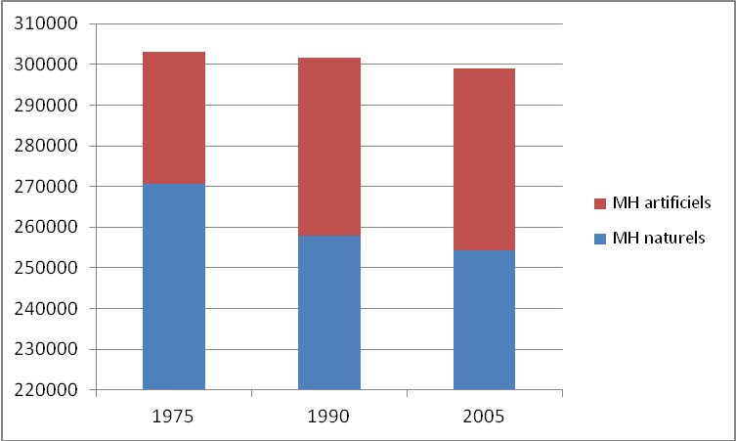

Overall in 30 years, natural wetland habitats have lost 6 % of their area, whilst manmade wetland habitats increased by 38 % within Ramsar Sites. Natural, non-wetland habitats decreased too.

These figures cannot be extrapolated to all wetlands in France overall, however.

- Marshes and lagoons, flooded forests and wet meadows are the wetland habitats that decreased most in area over 1975-2005. Conversely, manmade lakes and ponds increased most.

PHOTO COMPARATIVE MH Naturels / Artificiels

Agriculture pushed nature aside, but urbanisation has pushed agriculture aside

- Urban habitats increased significantly during 1975-2005 (+39 %), both within and around Ramsar Sites. However, agriculture remained stable or increased only slightly: +2% to +4% within the sites, -2 % to -3 % around them.
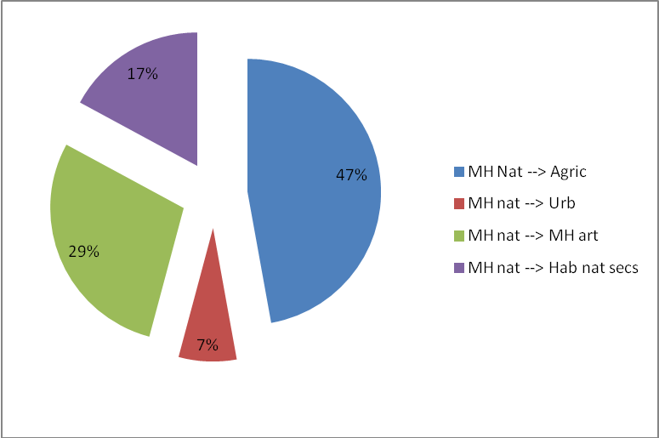
Half of the regression of natural wetlands (-16 400 ha in total) occurred through conversion to farmland, and almost 30% through conversion to man-made wetlands.
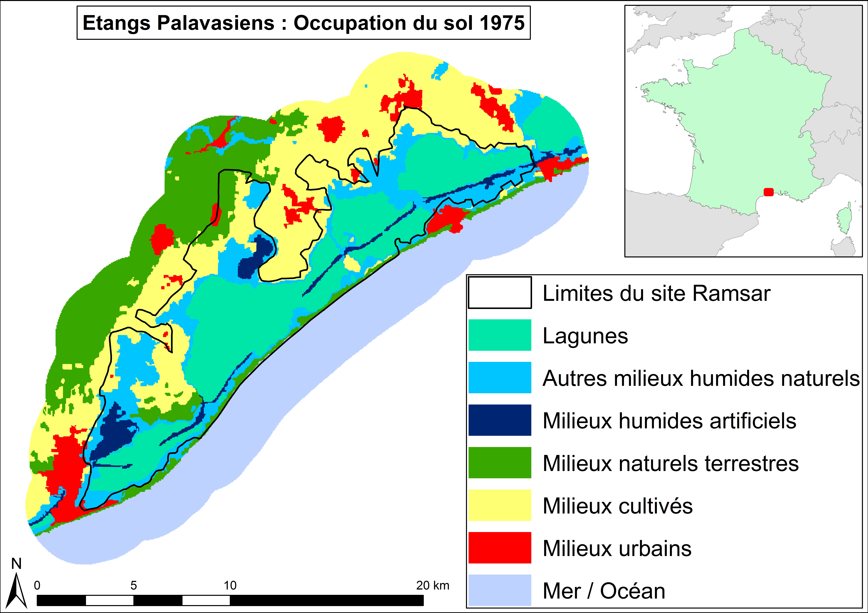
- Mediterranean, coastal Ramsar Sites were more affected by the development of cultivation and urban areas than those inland or along the western and northern coastlines.

- Some 60% of the rapid expansion of urban habitats within Ramsar Sites (+6200 ha) occurred on previous farmland.

- 85 % of the progression of farmland (+8200 ha), on the other hand, occurred on natural habitats, whether wet or drylands.

The loss of wetlands: slowing down?

Illustration ??
- Conversions of natural wetlands into farmland, urban areas or manmade wetlands seem to have slowed down in the period 1990-2005, as compared to 1975-1990. But overall, all other land conversions into urban areas have accelerated. Natural wetland habitats were thus the only ones escaping this rule: a result of positive public policies?

Testimonies :

“A crucial point demonstrated by the Observatory is that wetland surface areas continue to decrease even today, although our common objective is still to stop this process. We have not managed it so far, and this is not satisfying. Our wetlands will increasingly be recognized as playing a key role in protecting people and their belongings, so it is essential to stop their loss and degradation. In France, this will certainly require specific measures to promote and maintain animal husbandry within wetlands.
Luc BARBIER, Project officer for Audomarois marshes – Natural Regional Park “Caps et Marais d’Opale”

“The people and institutions that are behind the designation of these sites have perfectly understood that it is important not to focus on the core wetlands alone, but also to look at their surroundings. These often consist of more “ordinary” natural areas, but they play a key buffer role between the protected wetlands and the exploited areas that surround them. The Ramsar vision consists in integrating these areas on an equal footing within a conservation strategy.”
Patrick TRIPLET, Director, National Nature Reserve of the Somme Bay

The National Biodiversity Observatory (ONB) is a tool developed in order to monitor both the impacts of society on biodiversity and the interactions between society and biodiversity, as stated in the national strategy for biodiversity (SNB). Within this framework, the ONB proposes indicators and publishes its results on the web site http://indicateurs-biodiversite.naturefrance.fr/
The Wetlands Observatory is a special thematic focus of the ONB, which as such endorses this publication.
The technical report (in French) upon which this synthesis was developed can be downloaded here.

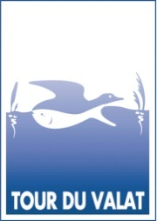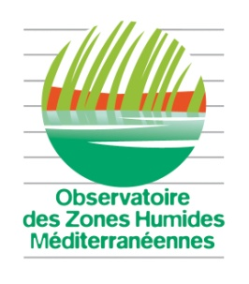

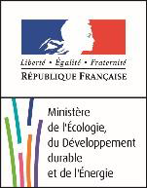
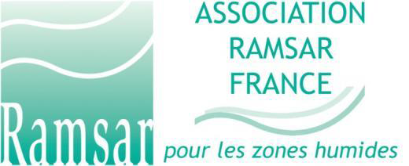
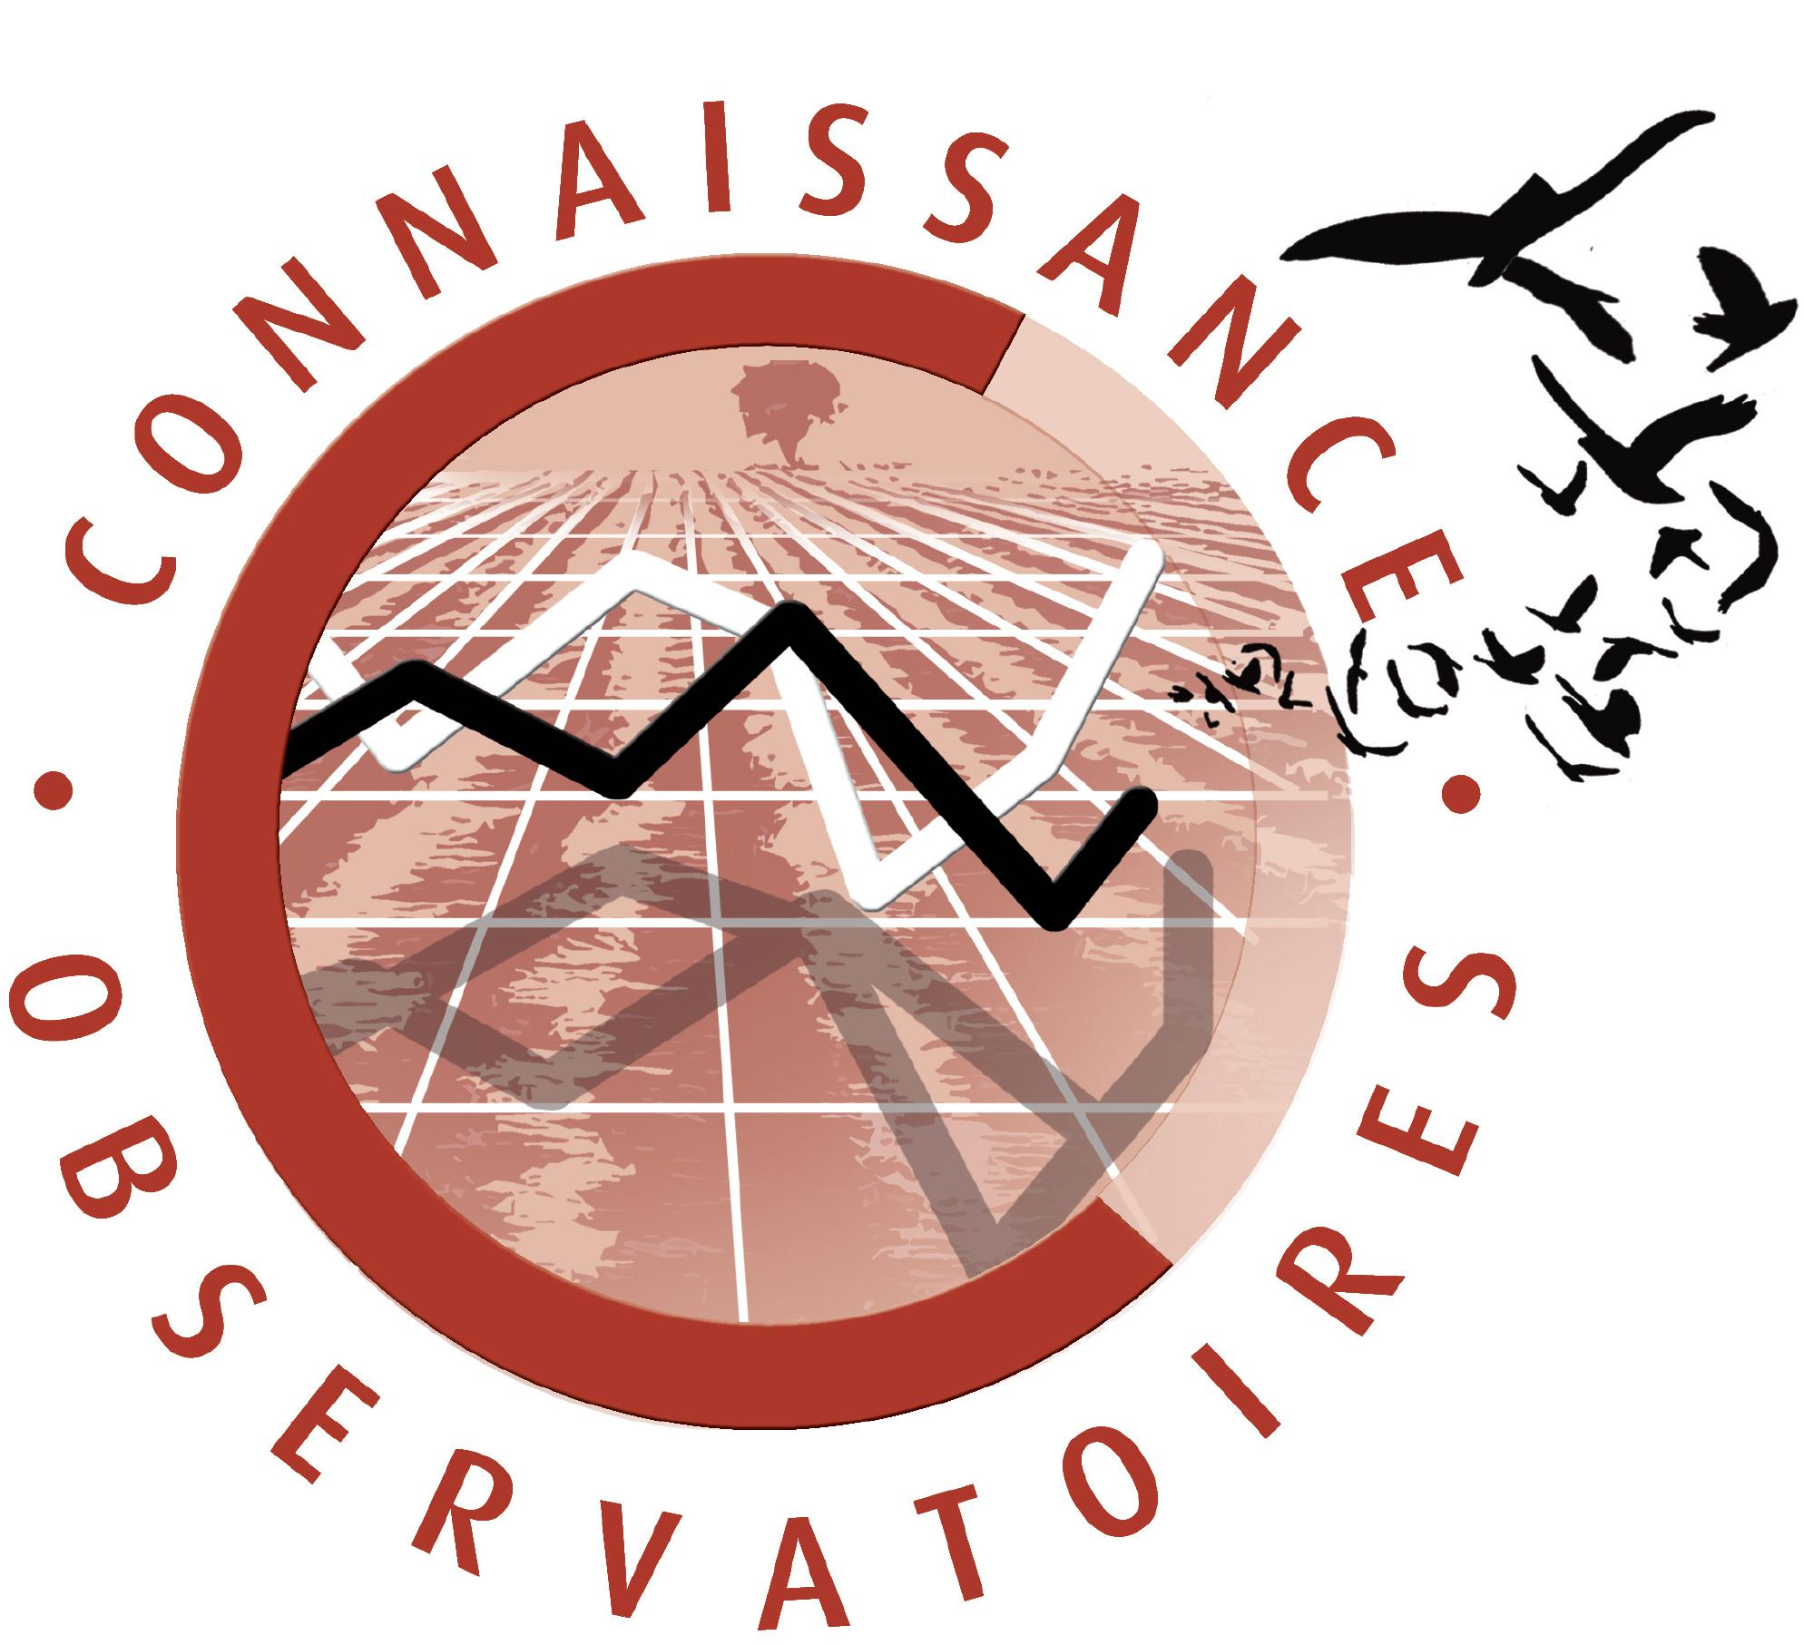+ logo ONMH

Include all habitats where water is prominent during at least part of the year , including purely aquatic environments. This corresponds to the Ramsar definition (wetlands in the broadest sense)
Dams and reservoirs, artificial ponds, salinas, fishponds, gravel pits, rice fields, etc.
designates all agricultural land except wet meadows, which were counted as “natural wetlands”. “Agriculture” therefore included farmland, orchards, dry meadows, etc., land-cover classes which were not analysed separately.

